
∑.E.M.
Releases notes v1.02

Releases notes
v1.02
Composant update 3
Bugs 3
Features 3
Order statu color on calendar 3
Gantt 3
Licence page 4
Task sort in prefil 4

Composant update
- Empty update

Bugs
- #85 No BOM on task manage
- #89 No task statu when order was generate from quote
- #95 We can creat wrong code on change type order
- #96 No control on location if we don’t have ressource

Features

Order statu color on calendar
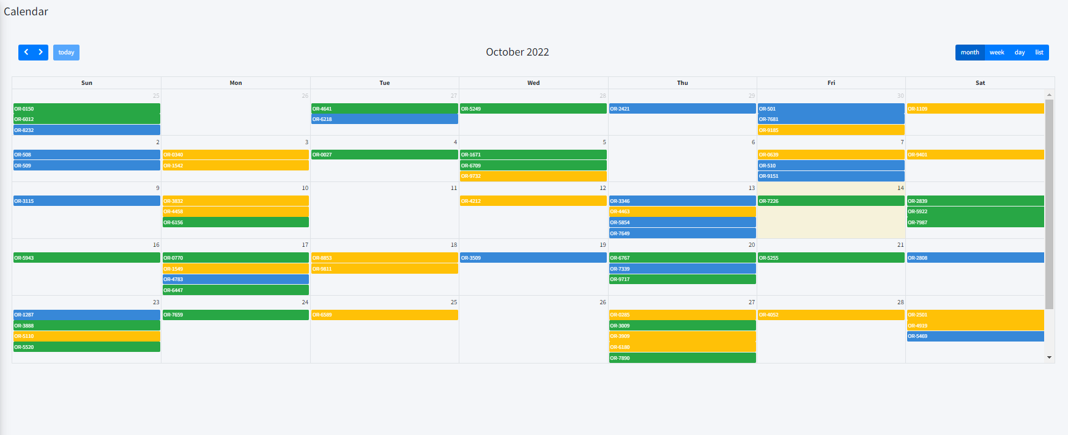

Gantt
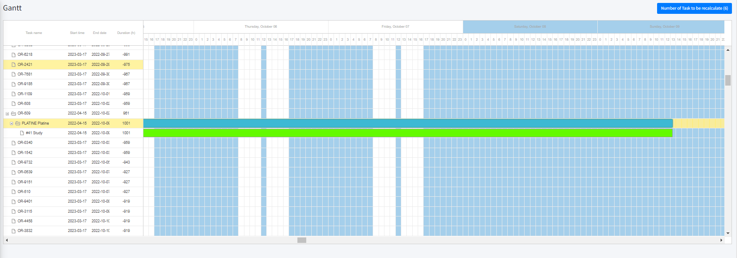

Licence page
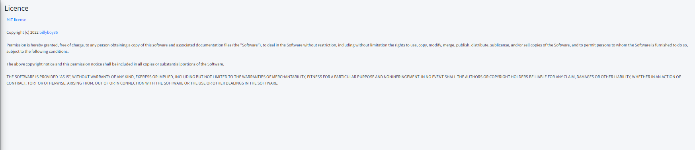

Task sort in prefil

